Font: Brittany
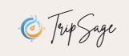
Font: Grand Hotel
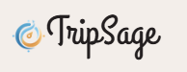
Font: Breathing
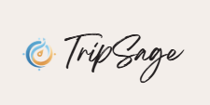

Background color: #f3eeea

Font Color: #f8f8f3

Accent Color: #90beab

Accent 2 Color: #a5a5a5


